Linux Assignment 5

Task 1 : Production Backup Simulation
1 : 1. Create at least 3 files in each directory.

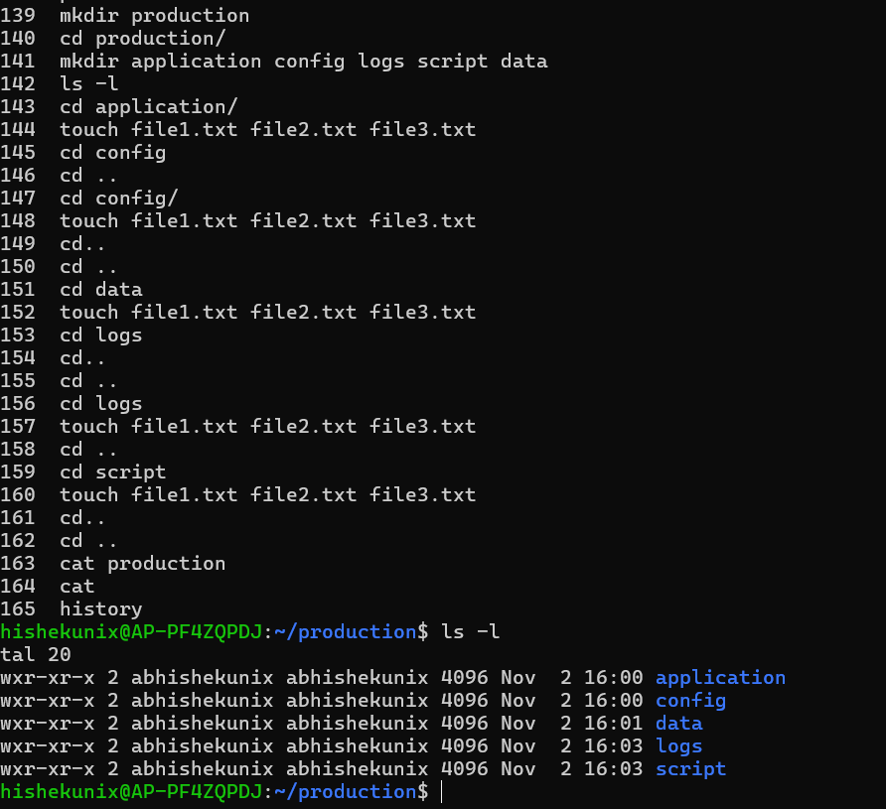
2 &3 Create a compressed backup of the entire application. (using tar and zip) 3. Display the archive contents without extracting.

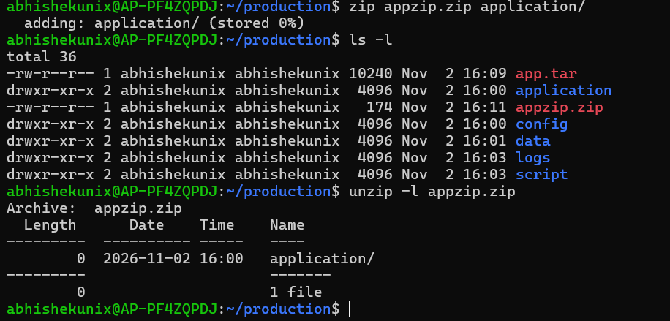

4: Extract it into /tmp/production_restore.
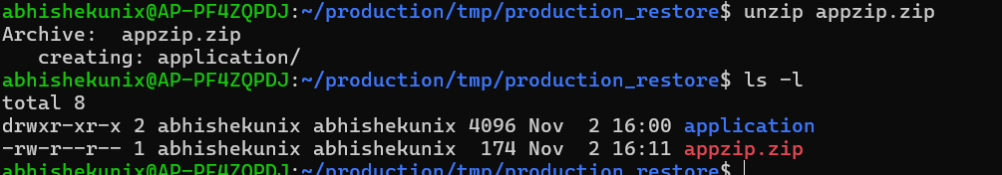

5: Verify that the complete directory structure and files are restored.
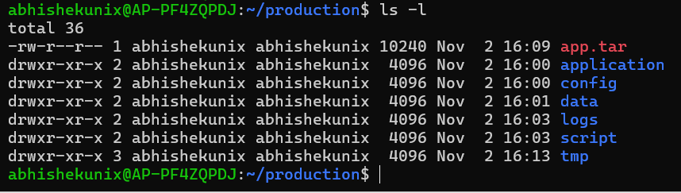
Task-2 - Configuration backup:
Create:

config/
â”œâ”€â”€ app.conf
â”œâ”€â”€ database.conf
â”œâ”€â”€ nginx.conf
â””â”€â”€ redis.conf
1. Create config_backup.tar.gz.
2. Delete the original config/ directory.
3. Restore it from the archive.

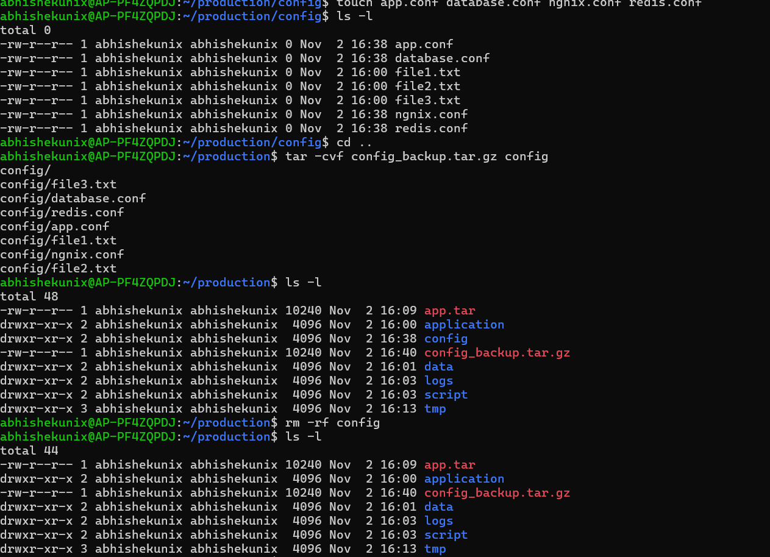

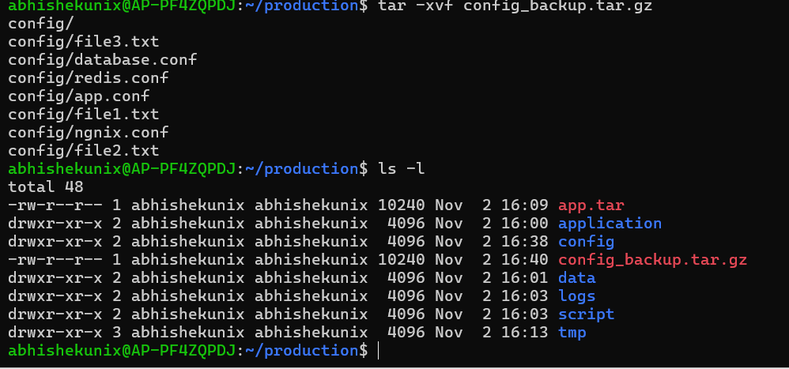
Task-3 - Add files to an existing tar archive:
----------------------------------------------

1. Create backup.tar containing file1.txt and file2.txt.
2. Create file3.txt.
3. Add file3.txt to the existing archive.
4. Verify the contents.
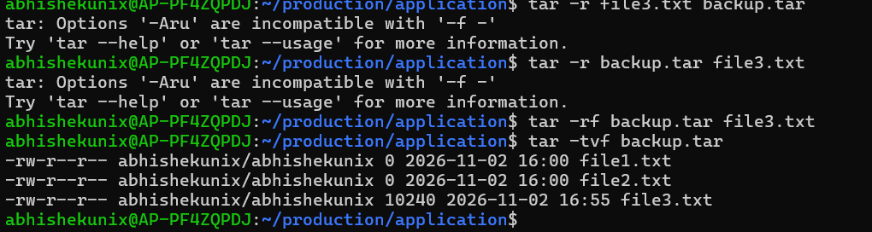
Task-4 - Selective Archiving:
-----------------------------
Archive only specific directories

Create application/ containing:
logs/
config/
data/
scripts/
1. Create an archive containing only logs/ and config/.

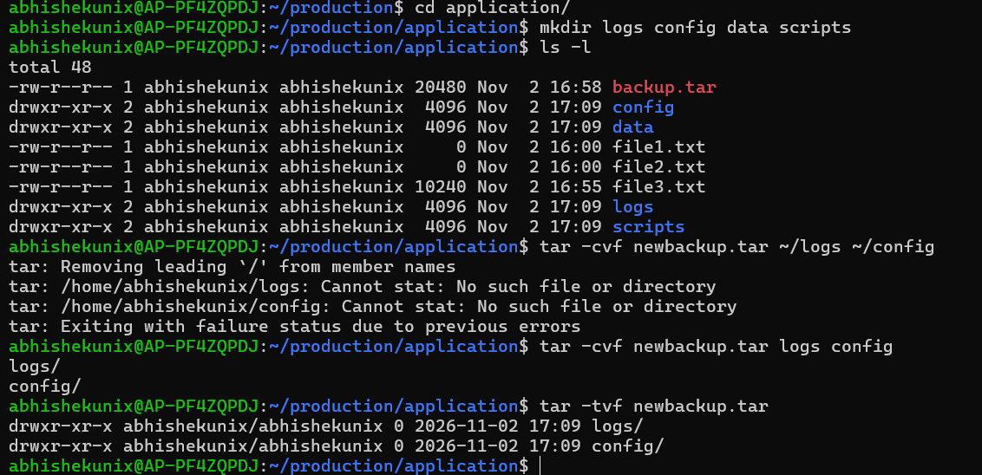

-------------------------------------

Create 5 files:

app.log
error.log
access.log
config.txt
README.txt

1. Create an archive backup.tar.gz containing only the three .log files.
2. List archive contents without extracting
3. Extract only error.log from the archive.
tar -xvf backup.tar.gz
tar -xvf backup.tar.gz | grep error.log
4. Now add config.txt file to an existing tar archive
5. Verify the contents.


